: How to Create and Configure ELB on AWS:

Configure Listeners for Your Load Balancer

To configure listeners for your load balancer

Sign in to the AWS Management Console and open the Amazon EC2 console at https://console.aws.amazon.com/ec2/.

Start the Create Load Balancer wizard:

On the Amazon EC2 console Getting Started page, in the EC2 Dashboard pane, under NETWORK & SECURITY, click Load Balancers.

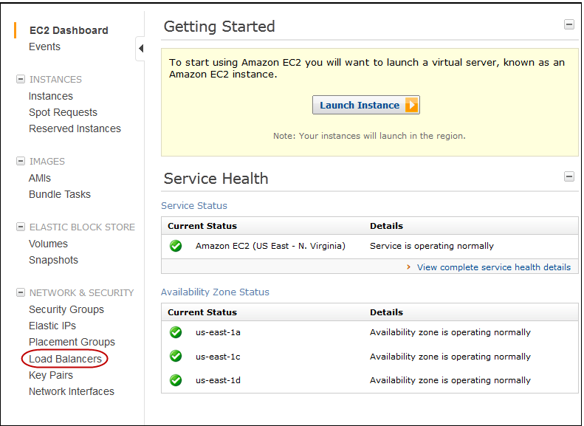

On the Load Balancers page, click Create Load Balancers.

On the DEFINE LOAD BALANCER page, make the following selections:

Enter a name for your load balancer (e.g., my-test-loadbalancer).
Leave CreateLB inside set to EC2 for this tutorial.

Leave Listener Configuration set to the default value for this example.

Important

The default settings require that your Amazon EC2 HTTP servers are active and accepting requests on port 80.
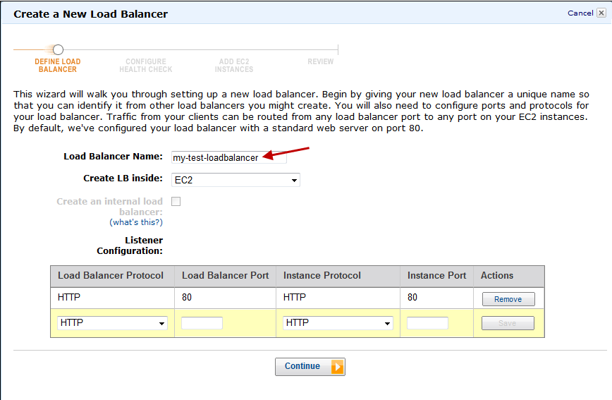

Click Continue to configure health check for your Amazon EC2 instances.

Configure Health Check for Your Amazon EC2 Instances

Elastic Load Balancing routinely checks the health of each load-balanced Amazon EC2 instance based on the configurations that you specify. If Elastic Load Balancing finds an unhealthy instance, it stops sending traffic to the instance and reroutes traffic to healthy instances.

To configure a health check for your Amazon EC2 instances

On the CONFIGURE HEALTH CHECK page of the Create a New Load Balancer wizard,
set the following configurations:

Leave Ping Protocol set to its default value of HTTP.
Leave Ping Port set to its default value of 80.
Elastic Load Balancing pings the port you choose (in this example, port 80) to send health check queries to your Amazon EC2 instances.

Important

Your Amazon EC2 instances must accept incoming traffic on the ping port. This example assumes that each of your instances has a working HTTP server that accepts incoming traffic on port 80.
In the Ping Path field, replace the default value with a single forward slash ("/").

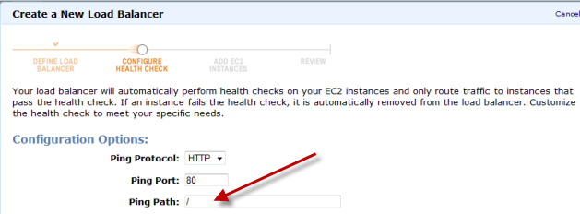

Elastic Load Balancing sends health check queries to the path you specify in Ping Path. This example uses a single forward slash so that Elastic Load Balancing sends the query to your HTTP server's default home page, whether that default page is named index.html, default.html, or a different name.
Leave the Advanced Options set to their default values.

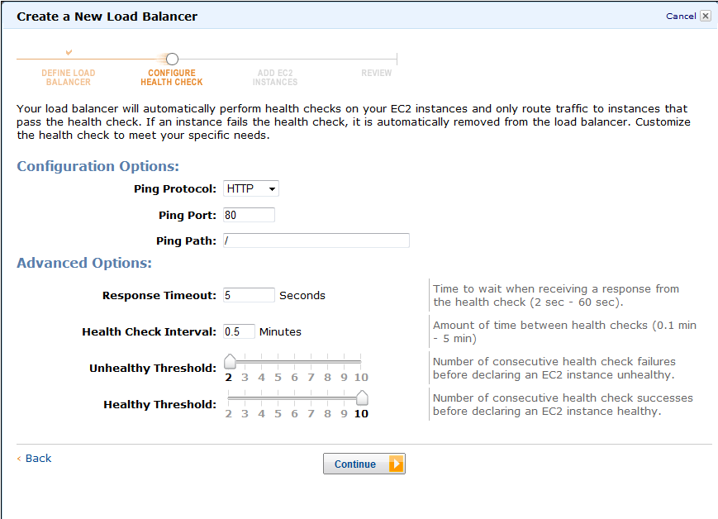

Click Continue to register your Amazon EC2 instances with your load balancer.
Register Amazon EC2 Instances

Now that you've made your configuration choices you're ready to register your EC2 instances using the ADD EC2 INSTANCES page of the Create Load Balancer wizard.
To register your Amazon EC2 instances

On the ADD EC2 INSTANCES page, check the boxes in the Select column to add instances to your load balancer.
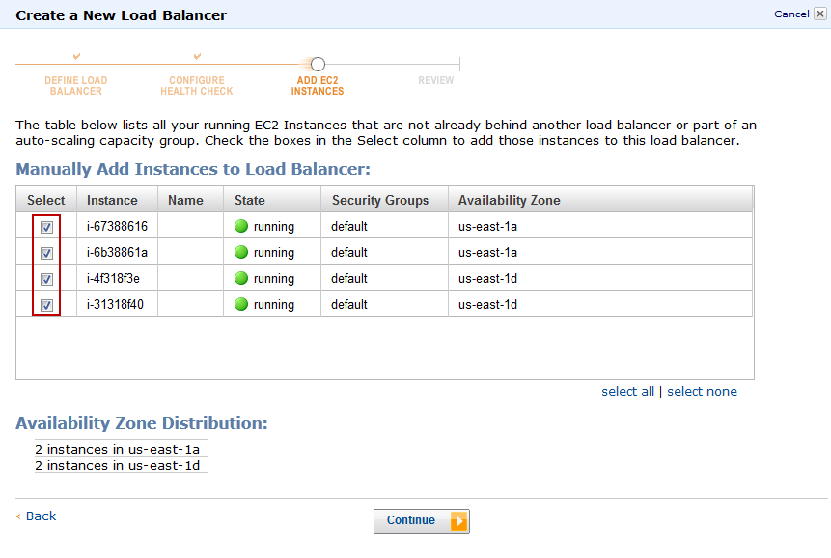
Click Continue to review your settings and then create your load balancer.

Review Settings and Create Your Load Balancer

Now that you've registered your EC2 instances with your load balancer it's time to review the settings you have selected.

To review your settings

On the REVIEW page of the Create a New Load Balancer wizard, check your settings. You can make changes by clicking the edit link for each setting.
Note

You can modify some of the settings even after you've created your load balancer. For example, you can modify the port configurations, health check configurations, and add or remove EC2 instances from your load balancer. For more information, see Using Elastic Load Balancing.

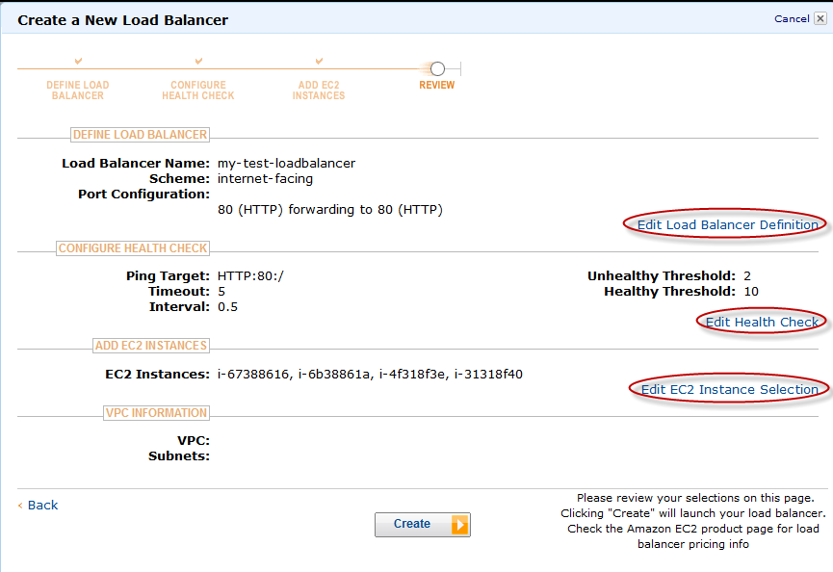

Click Create to create your load balancer.

Verify the Creation of Your Load Balancer

Now that you've created your load balancer, you're ready to verify its settings.
To verify creation of your load balancer

After you click Create button in the REVIEW page, a confirmation window opens. Click Close.

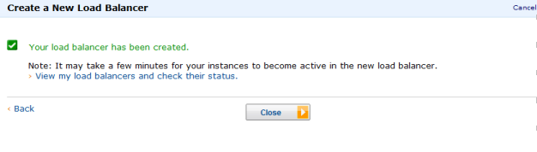
When the confirmation window closes, the Load Balancers page opens. Your new load balancer now appears in the list.

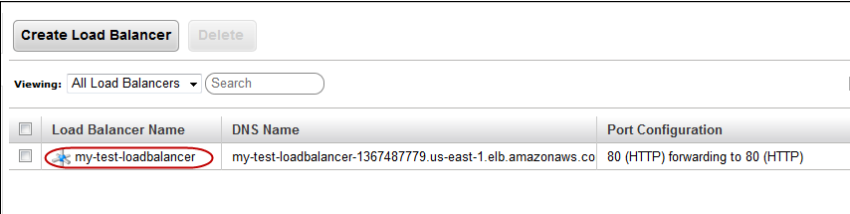

Select the check box next to your load balancer.

The Load Balancer selected pane displays the description of your load balancer. Verify that the descriptions match your specifications.

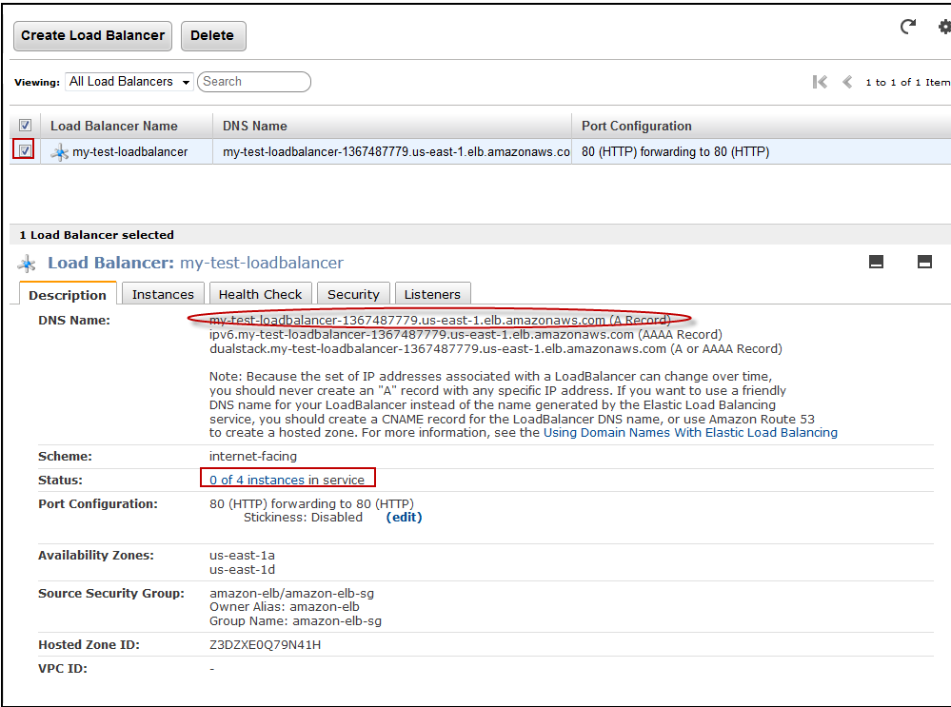

Reference: http://docs.aws.amazon.com/ElasticLoadBalancing/latest/DeveloperGuide/gs-ec2classic.html

